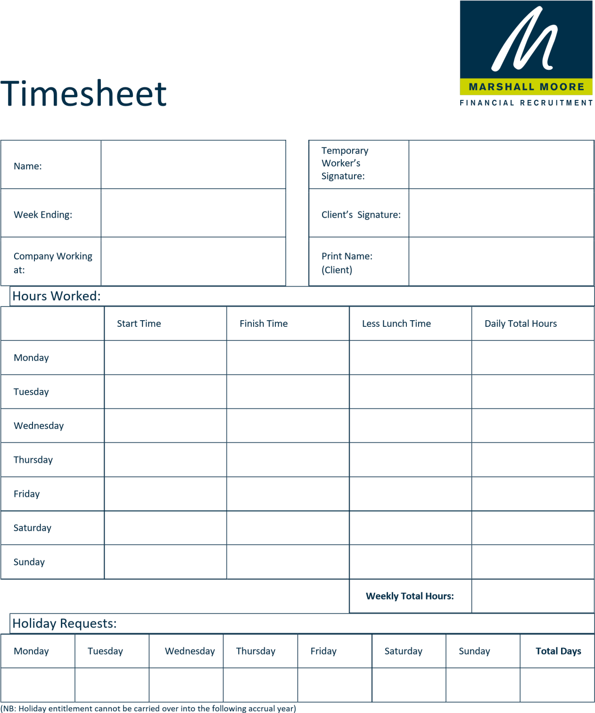

(NB: Holidays must be taken in the holiday year in which they are accrued and cannot be carried over to the following holiday year. Your annual holiday entitlement is 25 days plus bank holidays.)

Please ensure your signed timesheet is emailed by 10am each Monday to admin@marshallmoore.co.uk

